How to create deployment plan and deploy the content

1. Click on the below link <https://pfizerproukdev3.prod.acquia-sites.com/admin/structure/deploy>
2. In Top right, click on the Content Button

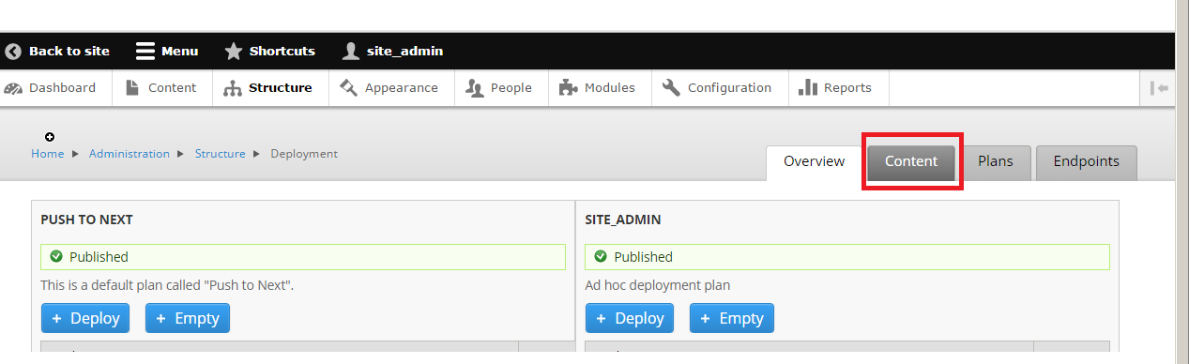

1. Now you will see all the content, scroll down in the page, you will find the link [create your own deployment plan](https://pfizerproukdev3.prod.acquia-sites.com/admin/config/content/deploy_addon/deploy_adhoc_plan?destination=admin/structure/deploy/content), hit the link.

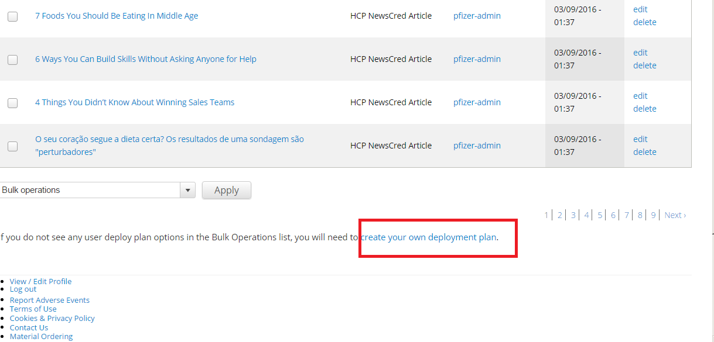

4. Click on **Create** button, your deploy plan will set by your name.

5. Now again click on content, and select the content you want to deploy.

6. In bottom left, you will find the dropdown, select **Add Node to user deploy plan**.

7. Hit the Apply button

8 .Now click on the deploy button and confirm content added by hitting the confirm button, all the content will be pushed to Stage.